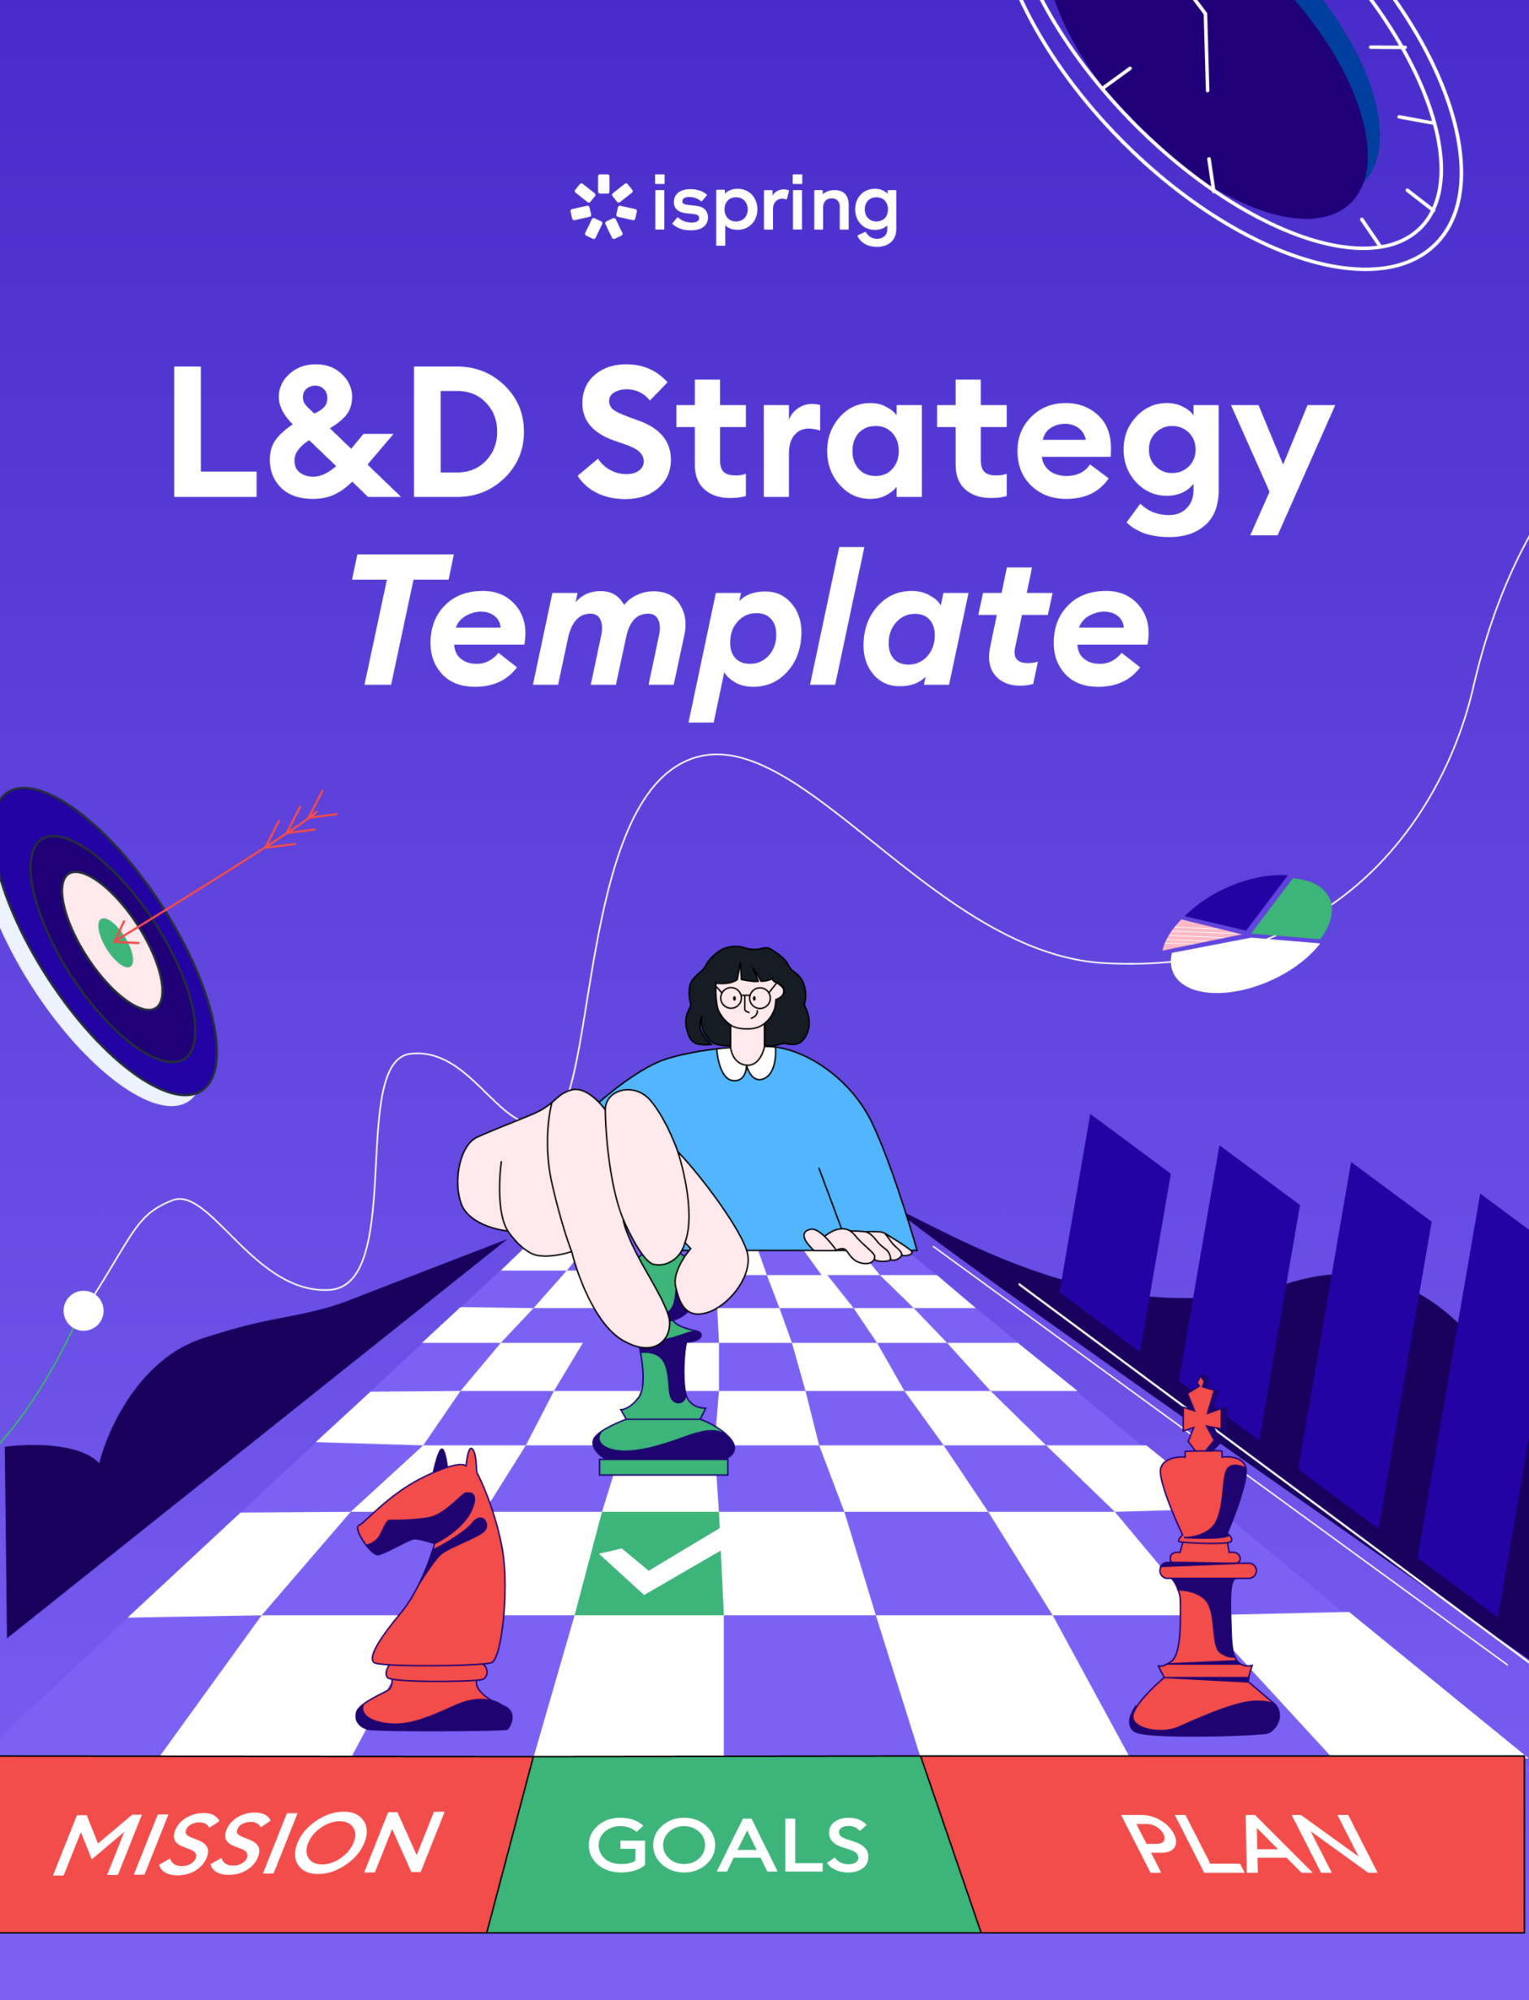

L&D Strategy Template

This template provides a starting point for developing an L&D strategy. Customize it to meet the specific context, needs, and goals of your organization.

Goals and Objectives

Learning  Goals | Define the specific areas of knowledge or skills that the L&D strategy aims to develop  (e.g., leadership, technical skills, or customer service skills).
Learning  Objectives | Set measurable objectives aligned  with business needs and employee development.

Organizational Analysis

Business Goals | Define key business objectives and specify how L&D can contribute to reaching them.
Workforce Assessment | Evaluate employees’ current skill levels, knowledge, and training needs.  Download our comprehensive training needs analysis template.
Skill Gaps | Identify skill gaps, ranking them by the priority of filling them.  Download our in-depth skill gap analysis template.

Vision and Mission

Vision  Statement | Define the organization’s long-term vision  for employee learning and development.
Mission Statement | State the purpose and guiding principles  of the L&D strategy.

Training and Development Initiatives

Program Overview | Provide an overview of the training  and development initiatives to be implemented.
Training  Methods | Specify the delivery methods to be used  for each program, such as classroom training, eLearning, on-the-job training, virtual classrooms, mobile learning, or workshops.
Content  and Curriculum | Lay out the topics, modules, and learning materials  to be included in the training programs.
Resources  and Support | List the resources, tools, and support needed  to realize effective training experiences.

Implementation Plan:

Timeline | Outline a timeline with key milestones and deadlines for each training initiative (include time allocated for adjustments).
Responsibilities | Assign roles and responsibilities to all stakeholders (HR, L&D, managers) involved in the implementation process.
Budget | Estimate the budget for each training initiative, including costs for eLearning tools, instructors,  and course authors.

Evaluation and Measurement:

Evaluation Methods | Define the evaluation methods and metrics that  will be used to measure the effectiveness of the training initiatives (pre and post-training assessments, learner feedback, etc.).
Continuous Improvement | Outline strategies for using evaluation results  to improve the L&D initiatives.

Stakeholder Engagement:

Communication  Plan | Detail how you will communicate the L&D strategy  to employees, managers, and other stakeholders (emails, all hands events, slack  announcements, etc.).
Continuous Improvement | Determine ways to involve and engage key stakeholders in the design, delivery,  and evaluation of the training programs  (e.g., champion programs).

